**Cognizant Week3_handsOn**

**Exercise 1: Configuring a Basic Spring Application**

**Code:**

**Main:**

package com.library;  
  
import com.library.service.BookService;  
import org.springframework.context.ApplicationContext;  
import org.springframework.context.support.ClassPathXmlApplicationContext;  
  
public class MainApp {  
 public static void main(String[] args) {  
 ApplicationContext context = new ClassPathXmlApplicationContext("applicationContext.xml");  
  
 BookService bookService = (BookService) context.getBean("bookService");  
 bookService.showBooks();  
 }  
}

**Library Repository**:

package com.library.repository;  
  
public class BookRepository {  
 public void displayBooks() {  
 System.*out*.println("Displaying list of books from the repository.");  
 }  
}

**Book Repository**:

package com.library.service;  
  
import com.library.repository.BookRepository;  
  
public class BookService {  
 private BookRepository bookRepository;  
  
 public void setBookRepository(BookRepository bookRepository) {  
 this.bookRepository = bookRepository;  
 }  
  
 public void showBooks() {  
 bookRepository.displayBooks();  
 }  
}

**Pom.xml:**

<project xmlns="http://maven.apache.org/POM/4.0.0"  
 xmlns:xsi="http://www.w3.org/2001/XMLSchema-instance"  
 xsi:schemaLocation="http://maven.apache.org/POM/4.0.0   
 http://maven.apache.org/xsd/maven-4.0.0.xsd">  
 <modelVersion>4.0.0</modelVersion>  
 <groupId>com.library</groupId>  
 <artifactId>LibraryManagement</artifactId>  
 <version>1.0-SNAPSHOT</version>  
  
 <dependencies>  
 <!-- Spring Context -->  
 <dependency>  
 <groupId>org.springframework</groupId>  
 <artifactId>spring-context</artifactId>  
 <version>5.3.31</version>  
 </dependency>  
 </dependencies>  
</project>

**Output:**

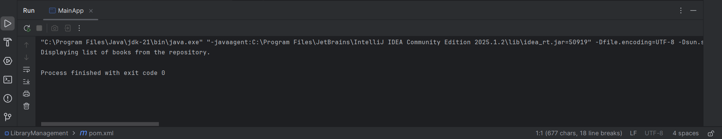

**Exercise 2: Implementing Dependency Injection**

**Code:**

**Main:**

package com.library;  
  
import com.library.service.BookService;  
import org.springframework.context.ApplicationContext;  
import org.springframework.context.support.ClassPathXmlApplicationContext;  
  
public class MainApp {  
 public static void main(String[] args) {  
 ApplicationContext context = new ClassPathXmlApplicationContext("applicationContext.xml");  
  
 BookService bookService = (BookService) context.getBean("bookService");  
 bookService.showBooks();  
 }  
}

**Book Repository**:

package com.library.repository;  
  
public class BookRepository {  
 public void displayBooks() {  
 System.*out*.println("Displaying list of books from the repository.");  
 }  
}

**Book Service**:

package com.library.service;  
  
import com.library.repository.BookRepository;  
  
public class BookService {  
 private BookRepository bookRepository;  
  
 public void setBookRepository(BookRepository bookRepository) {  
 this.bookRepository = bookRepository;  
 }  
  
 public void showBooks() {  
 bookRepository.displayBooks();  
 }  
}

**Pom.xml:**

**<project xmlns="http://maven.apache.org/POM/4.0.0"  
 xmlns:xsi="http://www.w3.org/2001/XMLSchema-instance"  
 xsi:schemaLocation="http://maven.apache.org/POM/4.0.0   
 http://maven.apache.org/xsd/maven-4.0.0.xsd">  
 <modelVersion>4.0.0</modelVersion>  
 <groupId>com.library</groupId>  
 <artifactId>LibraryManagement</artifactId>  
 <version>1.0-SNAPSHOT</version>  
  
 <dependencies>  
 <!-- Spring Context -->  
 <dependency>  
 <groupId>org.springframework</groupId>  
 <artifactId>spring-context</artifactId>  
 <version>5.3.31</version>  
 </dependency>  
 </dependencies>  
</project>**

**Output:**

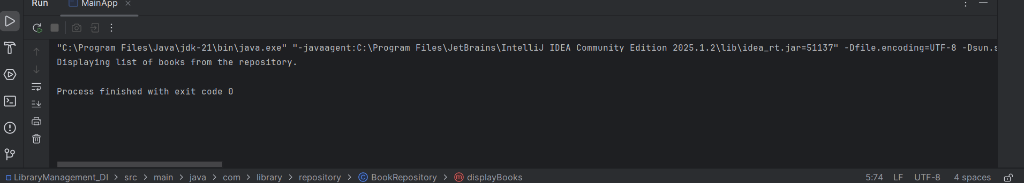

Exercise 4: Creating and Configuring a Maven Project

Code:

Main:

package com.library;  
  
import org.springframework.context.ApplicationContext;  
import org.springframework.context.support.ClassPathXmlApplicationContext;  
  
public class LibraryApp {  
 public static void main(String[] args) {  
 ApplicationContext context = new ClassPathXmlApplicationContext("beans.xml");  
 MessagePrinter printer = (MessagePrinter) context.getBean("printer");  
 printer.printMessage();  
 }  
}

**Message Printer**:

package com.library;  
  
public class MessagePrinter {  
 public void printMessage() {  
 System.*out*.println("✅ Spring Context Loaded Successfully! Library Management App is working.");  
 }  
}

**Pom.xml**:

<project xmlns="http://maven.apache.org/POM/4.0.0"   
 xmlns:xsi="http://www.w3.org/2001/XMLSchema-instance"   
 xsi:schemaLocation="http://maven.apache.org/POM/4.0.0   
 http://maven.apache.org/xsd/maven-4.0.0.xsd">  
  
 <modelVersion>4.0.0</modelVersion>  
 <groupId>com.library</groupId>  
 <artifactId>LibraryManagement</artifactId>  
 <version>1.0-SNAPSHOT</version>  
  
 <dependencies>  
 <dependency>  
 <groupId>org.springframework</groupId>  
 <artifactId>spring-context</artifactId>  
 <version>5.3.36</version>  
 </dependency>  
 <dependency>  
 <groupId>org.springframework</groupId>  
 <artifactId>spring-aop</artifactId>  
 <version>5.3.36</version>  
 </dependency>  
 <dependency>  
 <groupId>org.springframework</groupId>  
 <artifactId>spring-webmvc</artifactId>  
 <version>5.3.36</version>  
 </dependency>  
 <dependency>  
 <groupId>javax.servlet</groupId>  
 <artifactId>javax.servlet-api</artifactId>  
 <version>4.0.1</version>  
 <scope>provided</scope>  
 </dependency>  
 </dependencies>  
  
 <build>  
 <plugins>  
 <plugin>  
 <groupId>org.apache.maven.plugins</groupId>  
 <artifactId>maven-compiler-plugin</artifactId>  
 <version>3.10.1</version>  
 <configuration>  
 <source>1.8</source>  
 <target>1.8</target>  
 </configuration>  
 </plugin>  
 </plugins>  
 </build>  
  
</project>

**Output:**

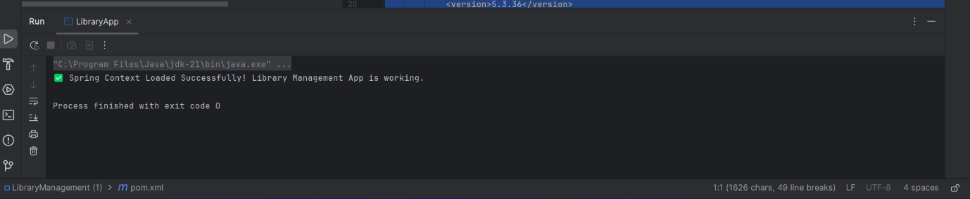

**Exercise1: Spring Data JPA - Quick Example**

**Code:**

**Main:**

package com.cognizant.ormlearn;  
  
import java.util.List;  
import org.slf4j.Logger;  
import org.slf4j.LoggerFactory;  
import org.springframework.boot.SpringApplication;  
import org.springframework.boot.autoconfigure.SpringBootApplication;  
import org.springframework.context.ApplicationContext;  
import com.cognizant.ormlearn.model.Country;  
import com.cognizant.ormlearn.service.CountryService;  
  
@SpringBootApplication  
public class OrmLearnApplication {  
  
 private static final Logger *LOGGER* = LoggerFactory.*getLogger*(OrmLearnApplication.class);  
 private static CountryService *countryService*;  
  
 public static void main(String[] args) {  
 ApplicationContext context = SpringApplication.*run*(OrmLearnApplication.class, args);  
 *countryService* = context.getBean(CountryService.class);  
 *LOGGER*.info("Inside main");  
 *testGetAllCountries*();  
 }  
  
 private static void testGetAllCountries() {  
 *LOGGER*.info("Start");  
 List<Country> countries = *countryService*.getAllCountries();  
 *LOGGER*.debug("countries={}", countries);  
 *LOGGER*.info("End");  
 }  
}

Country Service:

package com.cognizant.ormlearn.service;  
  
import java.util.List;  
import javax.transaction.Transactional;  
import org.springframework.beans.factory.annotation.Autowired;  
import org.springframework.stereotype.Service;  
import com.cognizant.ormlearn.model.Country;  
import com.cognizant.ormlearn.repository.CountryRepository;  
  
@Service  
public class CountryService {  
  
 @Autowired  
 private CountryRepository countryRepository;  
  
 @Transactional  
 public List<Country> getAllCountries() {  
 return countryRepository.findAll();  
 }  
}

Country Repository:

package com.cognizant.ormlearn.repository;  
  
import org.springframework.data.jpa.repository.JpaRepository;  
import org.springframework.stereotype.Repository;  
import com.cognizant.ormlearn.model.Country;  
  
@Repository  
public interface CountryRepository extends JpaRepository<Country, String> { }

**Country**:

package com.cognizant.ormlearn.model;  
  
import javax.persistence.*;  
  
@Entity  
@Table(name = "country")  
public class Country {  
  
 @Id  
 @Column(name = "co_code")  
 private String code;  
  
 @Column(name = "co_name")  
 private String name;  
  
 public String getCode() { return code; }  
 public void setCode(String code) { this.code = code; }  
  
 public String getName() { return name; }  
 public void setName(String name) { this.name = name; }  
  
 @Override  
 public String toString() {  
 return "Country [code=" + code + ", name=" + name + "]";  
 }  
}

**Application Properties**:

# Logging  
logging.level.org.springframework=info  
logging.level.com.cognizant=debug  
logging.level.org.hibernate.SQL=trace  
logging.level.org.hibernate.type.descriptor.sql=trace  
logging.pattern.console=%d{dd-MM-yy} %d{HH:mm:ss.SSS} %-20.20thread %5p %-25.25logger{25} %25M %4L %m%n  
  
# Database  
spring.datasource.driver-class-name=com.mysql.cj.jdbc.Driver  
spring.datasource.url=jdbc:mysql://localhost:3306/ormlearn  
spring.datasource.username=root  
spring.datasource.password=root  
  
# Hibernate  
spring.jpa.hibernate.ddl-auto=validate  
spring.jpa.properties.hibernate.dialect=org.hibernate.dialect.MySQL5Dialect

**Pom.xml**:

<project xmlns="http://maven.apache.org/POM/4.0.0"  
 xmlns:xsi="http://www.w3.org/2001/XMLSchema-instance"  
 xsi:schemaLocation="http://maven.apache.org/POM/4.0.0  
 http://maven.apache.org/xsd/maven-4.0.0.xsd">  
 <modelVersion>4.0.0</modelVersion>  
 <groupId>com.cognizant</groupId>  
 <artifactId>orm-learn</artifactId>  
 <version>0.0.1-SNAPSHOT</version>  
 <description>Demo project for Spring Data JPA and Hibernate</description>  
 <parent>  
 <groupId>org.springframework.boot</groupId>  
 <artifactId>spring-boot-starter-parent</artifactId>  
 <version>2.7.5</version>  
 <relativePath/>  
 </parent>  
 <dependencies>  
 <dependency>  
 <groupId>org.springframework.boot</groupId>  
 <artifactId>spring-boot-devtools</artifactId>  
 </dependency>  
 <dependency>  
 <groupId>org.springframework.boot</groupId>  
 <artifactId>spring-boot-starter-data-jpa</artifactId>  
 </dependency>  
 <dependency>  
 <groupId>mysql</groupId>  
 <artifactId>mysql-connector-java</artifactId>  
 </dependency>  
 </dependencies>  
 <build>  
 <plugins>  
 <plugin>  
 <groupId>org.springframework.boot</groupId>  
 <artifactId>spring-boot-maven-plugin</artifactId>  
 </plugin>  
 </plugins>  
 </build>  
</project>

**SQL Code:**

CREATE DATABASE IF NOT EXISTS ormlearn;

USE ormlearn;

CREATE TABLE country (

    co_code VARCHAR(2) PRIMARY KEY,

    co_name VARCHAR(50)

);

INSERT INTO country VALUES ('IN', 'India');

INSERT INTO country VALUES ('US', 'United States of America');

**Output**:

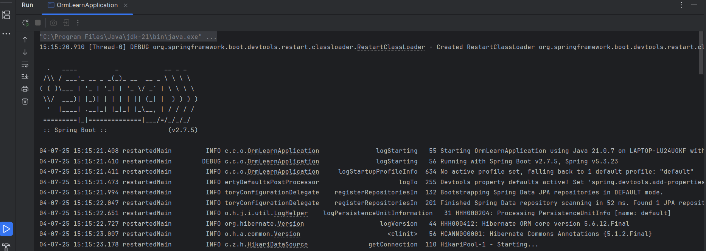

**Exercise 2: Diference between Jpa , Hybernate, and Spring data jpa:**

**JPA (Java Persistence API)**

JPA is just a specification, a set of rules and interfaces for ORM (Object-Relational Mapping) in Java.  
It tells you what to do but not how to do it. For example, JPA defines annotations like @Entity, @Id, and methods like persist(), but it doesn't provide the actual implementation.

You can't use JPA directly. It needs an implementation like Hibernate to actually manage the database interactions**.**

**Hibernate**

Hibernate is the most widely used implementation of JPA. It follows the JPA rules and also provides extra features that JPA does not cover, such as:

* First- and second-level caching
* Lazy loading
* Custom query language (HQL)
* Dirty checking (auto-detecting object changes)

You can use Hibernate with or without JPA. When used with JPA, Hibernate acts as the engine that actually saves and retrieves your objects from the database.

**Spring Data JPA:**

Spring Data JPA is a library provided by Spring to make working with JPA (and Hibernate) much easier.

Instead of writing your own repository classes with save/find/update logic, you simply create an interface, and Spring generates the code for you at runtime.

For example, you can write:

java

public interface CountryRepository extends JpaRepository<Country, String> {

List<Country> findByName(String name);

}

Spring Data JPA sits on top of JPA, and typically uses Hibernate under the hood.